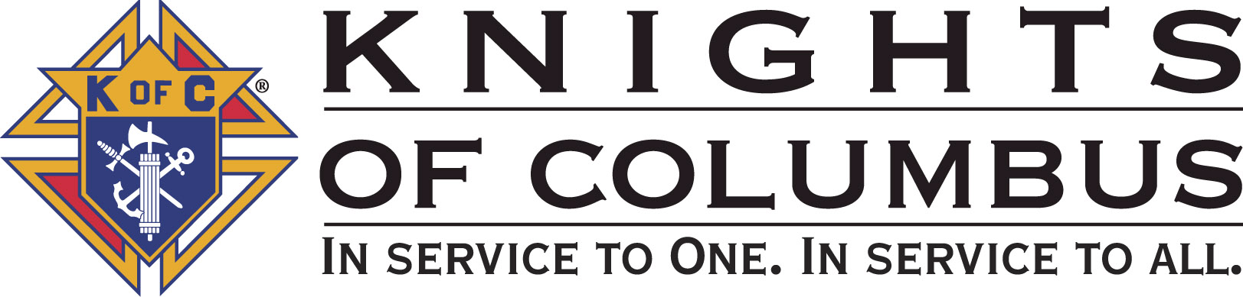

Council #13672 at Divine Savior Fr. Neil W. Seidl
Orangevale, CA
September 2010 Volume 9, #3

Monthly Grand Knight’s Message

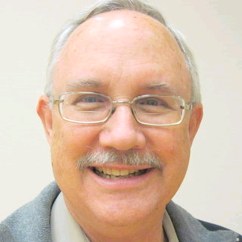
Grand Knight Bruce Pyle

Dep. Grand Knight Tony Aiello

Fin. Secretary Micheal Wagner

Treasurer Allen Brown

Chancellor Jack Hill

Warden Bob Reilly

Advocate Dave Brodie

Recorder Ray Coughlin

Trustee 1st Yr Charlie McDermott

Trustee 2nd Year Bill Windle

Trustee 3rd Year Mike Duskus

Inside Guard Douglas Copley

Outside Guard John Carvalho

Chaplin Fr. Roman Mueller

Lecturer Sam Cimino

Field Agent Tony Magdaleno

The Knights of Columbus Council #13672 at Divine Savior Fr. Neil W. Seidl Chapter meets Monthly on the First Tuesday of each month at 7:00 p.m.
Please join us to help our Catholic Community.
For insurance needs, please contact our Field Agent Tony Magdaleno at 470-9205 or by mail at
P.O. Box 2737
Rancho Cordova, CA 95741

Greetings Brother Knights:

Two new members took their 1st degree this past month, so please welcome Bill Baisley and Matt Peterson. Also welcome a member who transferred to our council, Nathaniel Harris.

In August, I attended a town hall meeting whose featured speaker was our new State Deputy, Ivan Reek. Brother Reek oversees the activities of some 590 councils in California. His theme: “I am my Brother’s keeper.” He talked about membership, retention, and follow-up.

* Membership: the more members we have, the more we can do. His observation is that at all levels, we have about 25-30% attendance at meetings—at all levels. So, our job, find ways to get people involved.
* Retention: It’s up to each of us to make ourselves the person that the new member wants to be around, and by our example, to be the person they want to be.
* Follow-up: He asked all members to contact their recruits and remind them of our meetings and everyone should welcome him to each meeting.

Brother Reek talked about religious vocations, and our role in spreading that word. And, he mentioned the need to promote the Columbian Charities.

I want to thank everyone who came forward and pulled the Octoberfest together, including but not limited to Charlie McDermott and Dan Freeman who got things started by contacting me while I was in SoCal, Allen Brown for agreeing to chair the event, and the rest of our volunteers.

Also, I want to thank everyone who attended the special meeting in August—we far surpassed the required voting quota and, as a result, had a very lively and productive officers meeting. Similarly, attendance at the general meeting in September was better than average with, by my count, 39 brothers. With fall approaching, there’s little else to do on the 1st Tuesday and last Thursday but to be involved in our council meetings. I encourage all our council members not just to attend, but also to help with as many events as they can. I hope to see you at the next meeting.

God bless us all.

Fraternally yours,

Bruce Pyle,
Grand Knight
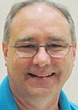

Treasurer Report
(Presented by Allen Brown)

KOC Council No. 132672 – Date balanced: 9/8/2010

Business: $12,587.72
CD50 - 52: $3,244.79
Charity: $711.64
Total: $16,544.15

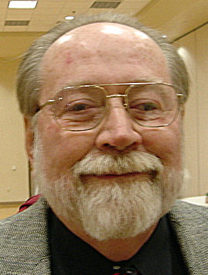

Financial Secretary’s Corner
(Presented by Michael Wagner)

Batch 56 $52.00
Raffle $52.00
Batch 57 $1129.43 Charity Account
Fireworks $1000.29
Pancake Breakfast #31 $129.14
Grand Total $1181.43


Fireworks Booth
The long awaited figures for the 2010 Fireworks Booths are in. We took in $34,784.39 on fireworks costing $17,809.03. Total expenses were $27,235.00 with net proceeds of $7,549.39. Our share is $4,001.17 and the Fair Oaks Rotary share is $3,548.21.

Bruce Pyle presented the Rotary their check on Sept. 13th. And, again, a big thanks goes to Bill Wagner and Jack Hill for all of their long hours and hard work.

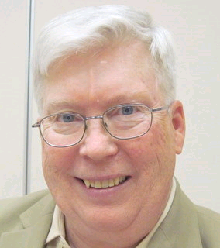

Recorder’s Motions
(As presented by Bill Mantos for Ray Coughlin)

Motions for September will be included in next months Newsletter.

Knight of the Month
(Presented by Bruce Pyle)

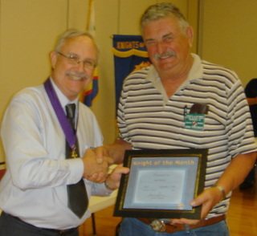
Our Knight of the Month for September is Dan Freeman.
A Past Grand Knight and current Director of the Church
Service Program, Dan has been involved in just about every Council activity including Fireworks, Strategic Planning, Retaining Wall, the recent Choir move, and the list goes on. When we learned that Die Alpine Band was available for the Octoberfest, Dan pulled together the right players to evaluate the feasibility of our doing this event, roped Allen Brown in chairing the event, and put the plans in place. He’s a
Brother Knight who just does what is necessary, when it’s necessary, and always “makes things happen.” Without him, our council would not be as strong and effective as it is.

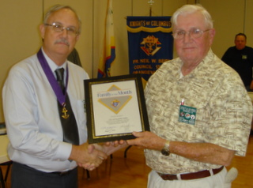

Families of the Month

(Presented by Bruce Pyle)

Accepting the award for the family of the month is John Padden. John and Jackie are a wonderful Catholic couple who have supported our parish almost from its inception. John, a Knight for 21 years and a PGK, is an EM and a very active member of St. Vincent de Paul. He was instrumental in creating our clothing locker and he built shelves for our expanded food closet. John worked tirelessly at our fireworks booth, hauled donations to the Treasure Fest, and spent the week in his motor home on site providing security for that event. Jackie is an EM and worked many hours at our Treasure Fest. She had been a member of the environmental committee and a REY instructor.

Special Award
(Presented by Bruce Pyle)
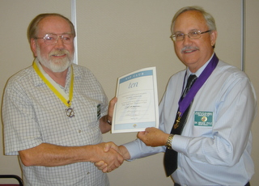
Michael Wagner joined the VIP (Very Important Proposer) Club Ten. Thank you Mike for the excellent job of recruiting ten new members!

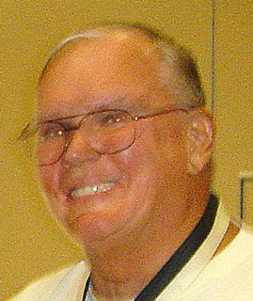

Let the Sunshine
(As presented by Jack Hill)

Cards are available to be sent out to members and families in need. For future need, please remember to contact Jack Hill with any sunshine activity or prayer cards that need to be sent.

You can contact Jack at 916-989-2106 or jack014@aol.com.

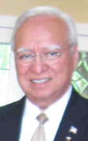
District Insurance News
(Presented by Tony Magdaleno)
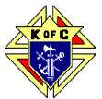

KNIGHTS OF COLUMBUS INSURANCE
KNIGHTS OF COLUMBUS INSURANCE
“YOUR SHIELD FOR LIFE”
September is Life Insurance Awareness Month.
To help educate consumers about the need for and value of adequate life insurance protection, the Life Insurance Market Research Association (LIMRA) has published the following five facts. These statistics are certainly worth considering.
Fact 1: Nearly three-fourths of North Americans agree that life insurance is the best way to protect against premature death of the primary wage earner.
Fact 2: Twenty-four million households have no life insurance protection at all. Almost one third of adults have no life insurance protection.
Fact 3: Forty-four percent of all households either don’t own life insurance or believe they should, or own life insurance and believe they need more. Among those that already own some life insurance, 40 percent believe they don’t have enough.
Fact 4: One-fourth of primary wage earners feel they do not have a plan in place to provide a decent standard of living for their family if they died tomorrow. Twelve percent of families would immediately have trouble meeting everyday living expenses and another 15 percent would have difficulty keeping up after several months.
Fact 5: People would like to discuss life insurance with a qualified professional agent. They believe that buying life insurance is an important and complex financial decision. Half find it difficult to decide how much to buy, and 43 percent worry about making the wrong decision.
I’d like to meet with you in your home, at your convenience. I’ll work with you to make sure your family is protected. As you’re brother Knight, trust that I will take the stress and worry out or your decision-making.
Please call (916) 470-9205 or e-mail me at tony.magdaleno@kofc.org with any questions you may have. I’m your full time Field Agent…

Fraternally, Your Brother,
Tony Magdaleno
FA # 14661
CA Lic. # OG27147

Committee Report - Membership
(Presented by Ray Coughlin)

Our membership tally is now at 129 members.

If you know of someone who would like to join our council, please refer them to Ray Coughlin at (916) 989-4226 or Tony Magdaleno at (916) 470-9205.

Welcome New Members!
(Presented by Bruce Pyle)
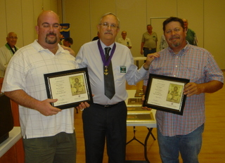
Please welcome two of our newest Knights William Baisley and Matt Peterson.

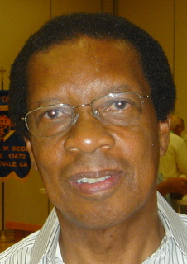
Welcome Transfer Knight

Please welcome Nathaniel Harris to our Knights of Columbus Council #13672. Nate is a recent transfer from the Holy Family Knights of Columbus

Second and Third Degrees
Attention all First Degree Knights, the next second and third degrees will be in early November in Rancho Cordova. Please look at your calendar as someone will be calling you to invite you to attend. Call will be made when the specific date and time is announced.
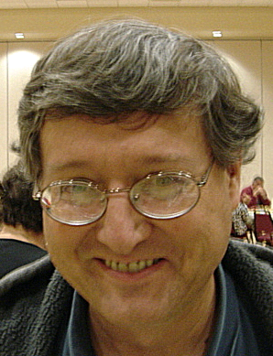

Committee Report - Youth
(Presented by Bill Manos)

We have received 3-4 scholarship applications and hopefully waiting for a couple more. Getting ready to meet with trustees to choose winners.
Soccer competition to be held at St John’s in Folsom and we have several players competing. Please contact Bill Manos at 965-3834 with any Youth Service Program questions.

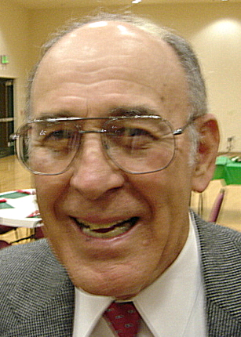

Committee Report - Family
(Presented by Guy Sanchez)
Family – Guy Sanchez – Planning for Christmas social and looking for a brother to come forward and take the reins to be chairman for this special.
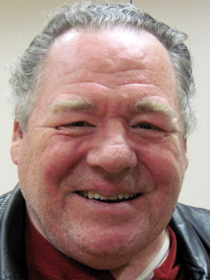
Please contact Guy Sanchez at 965-3834 with any Family Service Program questions.

Committee Report – Council
(Presented by Bill Windle)

Our next pancake breakfast and blood drive will be Sept. 19th. Adults are $7.00, children $3.00 and $17.00 for families. Doug Copley has agreed to co-chair this one. We are seeking another co-chair.

Please contact Bill Windle at 988-2239 with Council Service Program questions.

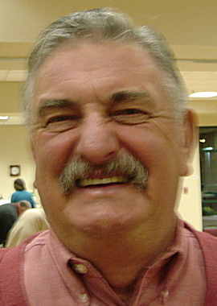

Committee Report – Church
(Presented by Dan Freeman)

A Strategic Planning meeting to be held from 9:00 am to approx @2:00 pm on Sat. Sept. 25th.
Oktoberfest will be held on Sat. Sept 18th from 5:30 to ??? Great food, Great band and guarantee lots of fun. Tickets are adults-$18.00, children, $8.00. Tickets will be available at the door.
Our chairman of this event is Allen Brown and he could still use more help. Call Allen989-6846.

The Mather Air show was held Sat and Sun Sept 11th -12th, and was a great success, we had 6 members work a booth with another organization selling Pizza’s and water. Joe Luchi chaired this event that was attended by over 100,000 people.
Please contact Dan Freeman at 987-0908 with any Church Service Program questions.

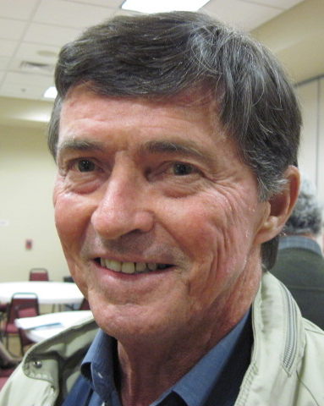
Committee Report - Community
(Presented by Tom Hogan)

Community –Tom Hogan –Our ID drive/ tootsie roll fund raiser will be held in Oct., It will be chaired by Dave Brodie and he could use help as we want to have a very successful fund raiser by working the 2 stores, and contacting local business and companies. Call Dave @ 988-6678 to sign up.

Please contact Tom Hogan at 988-2184 with any Community Service Program questions

Future Council Planning Report
(Presented by Bruce Pyle)

Our new officers will have a Strategic Planning meeting will be held on Sat. September 25th, starting at 9:00 am and chaired by Dan Freeman.

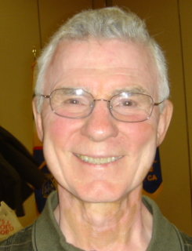

Committee Report – Culture of Life
(Presented by Mike Schaefer)

PRO-LIFE NEWS & ACTIVITIES for September 2010

As Knights are truly a Pro-Life organization, please participate, and invite others to join you, in a PL activity this month and the days ahead.

Because children are a “gift from God”, they can neither be demanded nor discarded. That is why it is wrong not only to abort children, but also to create children through artificial means (cloning) that replace normal human procreation.

There is only one workshop remaining of four scheduled titled, STOPPING PLANNED PARENTHOOD which is being presented by Jim Sedlak, American Life League, and David Bereit, founder of 40 Days for Life. It will be held in the large conference room at St Joseph Catholic Church, Auburn, CA on September 14 at 7:00pm. (Call Penny @ 530-885-9055)

A Pro-Life Mass is held monthly (2nd Tuesday @ 6:00pm) at St Philomene’s Church located at 2428 Bell Ave. The next Mass will be September 14th. (Call Sally @ 916-721-0378)

40 Days-For-Life is scheduled for September 22nd to October 31st. Our Council will be represented each Thursday for 1 or 2 hours at the Pregnancy Consultation abortion clinic at 53rd & F Street to pray the Rosary to end abortions. We will start on Sept 23rd by attending Mass at 8:30 am at Divine Savior, ask for Fr Roman’s blessing, and then travel in a group to the clinic. This is a family activity, so spouses and friends are welcomed. A sign-up sheet will be available at the Sept & Oct Business meetings.

Plan to attend the Bishop Gallegos Maternity Home Annual Fund Raising Dinner on September 26 at the Dante Club on Fair Oaks Blvd starting at 5:00pm. Fr Patrick Lee will be honored for his pro-life activities. (Call Kathy @ 916-337-6824)

The KCs will hold their 6th annual Chili Cook-off at Newman Center Court near Sac State on October 2nd to benefit both the Bishop Gallegos maternity Home and the Sacramento Life Center.

The Sacramento Life Center will hold their Salute to Life Dinner & Auction on Saturday November 13. (Please call 916-451-4357 for information.)

Elections are quickly approaching (1st Tuesday in November). Become astute listeners to the campaign promises being made. Remember, there are 5 NON-NEGOTIABLE issues that the Catholic Church lists as intrinsically evil as they conflict with moral law and cannot be condoned or deliberately performed under any circumstances. These are: ABORTION, EUTHANASIA, EMBRYONIC STEM CELL RESEARCH, HUMAN CLONING AND HOMOSEXUAL MARRIAGE.

Any questions to the above can be addressed to Mike Schaefer at 916/988-3171.

Special Prayer Intentions

Please keep the following people in your prayers:

- Zoe Mann- wife of Steve (Kidney removal)
- Tom Lawson (cancer)
- Rich Dean (chemo- cancer)
- Mary Trujillo- wife of Peter (asthma)
- Peter Burriesce (dialysis/foot healing)
- Denise Ash- sister of Bill Wagner (cancer)
- April Paulitz- wife of Patrick (cancer)
- Debbie McDermott- wife of Charlie McDermott (dementia)
- Julia Rapier- mother of Joe Rapier (memory)
- Sick: Barbara Lawson, Paul Pyle, Ladene Carvalho, Eldon Hancock,
Earl Varney, Martin Jennings, Jack Joiner and Beverly Ridge
- Deceased: Frank Stuto- father of Tom & Barbara Lawson
- Deceased: Robert Howe


September / October Birthday List

Joseph (Joe) Paddock | 3-Sep
Curt Taras | 7-Sep
David Chacon | 8-Sep
Thomas Sekel | 10-Sep
Anthony (Tony) Aiello | 12-Sep
Wm Presley King | 12-Sep
Thomas Hogan | 13-Sep
Jeffrey Mangum | 17-Sep
Patrick Paulitz | 18-Sep
Simon Herrman | 22-Sep
John Ledesma | 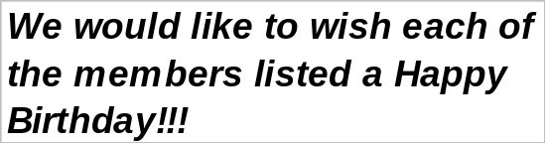  24-Sep
George Zettel | 26-Sep
Marc Pascual | 28-Sep
Frank Donner Jr | 6-Oct
Michael Dreiling | 8-Oct
Clemente Torres Sr | 9-Oct
William (Bill) Smith | 13-Oct
Andrew Ventimiglia | 14-Oct
William (Bill) Windle | 27-Oct
Jack Dube | 30-Oct

Calendar of Events

2010
Date | Event | Day/Time | Location
7-Sep | General Meeting | Tues 7:00 | DS Parish Hall
Sep 11-12 | Mather Air Show | Sat-Sun | Mather
11-Sep | Soccer Shootout | Sat | St. John Baptist
18-Sep | Oktoberfest | Sat | DS Parish Hall
19-Sep | Pancake Breakfast and Blood Drive | Sun | DS Parish Hall
30 Sep | Officers/Planning | Thurs 7:00 | DS Parish Hall
25-Sep | Strategic Planning Meeting | Sat 9:00am | DS Parish Hall
5-Oct | General Meeting | Tues 7:00 | DS Parish Hall
Oct 15-17 | IR (Tootsie Roll) | Wal Mart | 2 locations
28-Oct | Officers/Planning | Thurs 7:00 | DS Parish Hall
2-Nov | General Meeting | Tues 7:00 | DS Parish Hall
Nov (TBD) | 2nd and 3rd Degree | Sat | TBD
18-Nov | Officers/Planning | Thurs 7:00 | DS Parish Hall
21-Nov | Corp. Communion Memorial Mass | Sun 7:45 | Church
3-Dec | Christmas Social | Friday | DS Parish Hall
7-Dec | General Meeting | Tues 7:00 | DS Parish Hall
16-Dec | Officers/Planning | Thurs 7:00 | DS Parish Hall
2011
Date | Event | Day/Time | Location
4-Jan | General Meeting | Tues 7:00 | DS Parish Hall
Jan (TBD) | Free Throw |  | St. John’s
16-Jan | Pancake Breakfast | Sun | DS Parish Hall
16-Jan | Blood Drive | Sun | DS Parish Hall
22-Jan | Walk for Life, SF | Sat | Bus to SF
27-Jan | Officers/Planning | Thurs 7:00 | DS Parish Hall
 | Events Legend:
 | Yellow: Officers / Planning Meeting / General Meeting
 | Green: Fundraisers
 | Pink: Social Events

